**`5Assignment 6**

21AIE111

Data Structure and Algorithms – SEM-II

Professor – Dr. Sachin Sir

Submitted By: Vikhyat Bansal [CB.EN.U4AIE21076]



1. Write java code to create a binary tree using arrays.

CODE:

// *JAVA implementation of tree using array*

// *numbering starting from 0 to n-1.*

import *java*.*io*.*\**;

import *java*.*lang*.*\**;

import *java*.*util*.*\**;

*class* BTreeArr {

  // *Main driver method*

*public* *static* void *main*(String[] args)

  {

    // *Creating object of class 2 inside main() method*

    Array_imp tree = *new* *Array_imp*();

    //*Setting root node*

    /* *Our tree from this input will look something like this*\*/

    /* *A(0)*

*/    *

*/      *

*/        *

*B(1)            C(2)*

*/   \            /   *

*/     \          /     *

*D(3)       E(4)     F(5)    G(6)*

*/   \     /   \    /       /   *

*H(7)     I(8)*\*/

    tree.*Root*("A");

    tree.*set_Left*("B", 0);

    tree.*set_Right*("C", 0);

    tree.*set_Left*("D", 1);

    tree.*set_Right*("E", 1);

    tree.*set_Left*("F", 2);

    tree.*set_Right*("G", 2);

    tree.*set_Left*("H", 3);

    tree.*set_Left*("I", 4);

    tree.*print_Tree*();

  }

}

*class* Array_imp {

  // *Member variables of this class*

*static* int root = 0;

*static* String[] str = *new* String[10]; //*Array is limited to n amount of nodes*

*public* void *Root*(String key)

  { str[0] = key; }

*public* void *set_Left*(String key, int root)

  {

    int t = (root * 2) + 1;

*if* (str[root] == null) {

      System.*err*.*println*();

      System.*out*.*printf*(

        "Can't set child at " +t+", no parent found");

    }

*else* {

      str[t] = key;

    }

  }

*public* void *set_Right*(String key, int root)

  {

    int t = (root * 2) + 2;

*if* (str[root] == null) {

      System.*out*.*println*();

      System.*out*.*printf*(

        "Can't set child at " +t+", no parent found"

        );

    }

*else* {

      str[t] = key;

    }

  }

*public* void *print_Tree*()

  {

    System.*out*.*println*();

    // *Iterating using for loop*

*for* (int i = 0; i < 10; i++) {

*if* (str[i] != null)

        System.*out*.*print*(str[i] +  " ");

*else*

        System.*out*.*print*("-");  // *printing '-' if node is null and a node is missing in connection.*

    }

  }

}

OUTPUT:

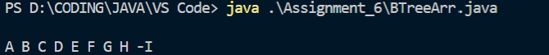

2. Write java code to create a binary tree using linked list.

CODE:

// *Java program to create complete Binary Tree from its Linked List*

// *representation*

// *importing necessary classes*

import *java*.*util*.*\**;

// *A linked list node*

*class* Driver {

    // *Driver program to test above functions*

*public* *static* void *main*(String[] args)

    {

        BinaryTree tree = *new* *BinaryTree*();

        tree.*push*(1); /* *Last node of Linked List* */

        tree.*push*(5);

        tree.*push*(10);

        tree.*push*(15);

        tree.*push*(20); /* *First node of Linked List* */

        BinaryTreeNode node = tree.*convertList2Binary*(tree.*root*);

        System.*out*.*println*("Inorder Traversal of the"+

                        " constructed Binary Tree is:");

        tree.*inorderTraversal*(node);

/* *We can use different traversals to go through the tree. */*

    }

}

*class* ListNode

{

    int data;

    ListNode next;

*ListNode*(int d)

    {

        data = d;

        next = null;

    }

}

// *A binary tree node*

*class* BinaryTreeNode

{

    int data;

    BinaryTreeNode left, right = null;

*BinaryTreeNode*(int data)

    {

        this.*data* = data;

        left = right = null;

    }

}

*class* BinaryTree

{

    ListNode head;

    BinaryTreeNode root;

    // *Function to insert a node at the beginning of*

    // *the Linked List*

    void *push*(int new_data)

    {

        // *allocate node and assign data*

        ListNode new_node = *new* *ListNode*(new_data);

        // *link the old list off the new node*

        new_node.*next* = head;

        // *move the head to point to the new node*

        head = new_node;

    }

    // *converts a given linked list representing a*

    // *complete binary tree into the linked*

    // *representation of binary tree.*

    BinaryTreeNode *convertList2Binary*(BinaryTreeNode node)

    {

        // *queue to store the parent nodes*

        Queue<BinaryTreeNode> q =

*new* LinkedList<BinaryTreeNode>();

        // *Base Case*

*if* (head == null)

        {

            node = null;

*return* null;

        }

        // *1.) The first node is always the root node, and*

        // *add it to the queue*

        node = *new* *BinaryTreeNode*(head.*data*);

        q.*add*(node);

        // *advance the pointer to the next node*

        head = head.*next*;

        // *until the end of linked list is reached, do the*

        // *following steps*

*while* (head != null)

        {

            // *2.a) take the parent node from the q and*

            // *remove it from q*

            BinaryTreeNode parent = q.*peek*();

            // *2.c) take next two nodes from the linked list.*

            // *We will add them as children of the current*

            // *parent node in step 2.b. Push them into the*

            // *queue so that they will be parents to the*

            // *future nodes*

            BinaryTreeNode leftChild = null, rightChild = null;

            leftChild = *new* *BinaryTreeNode*(head.*data*);

            q.*add*(leftChild);

            head = head.*next*;

*if* (head != null)

            {

                rightChild = *new* *BinaryTreeNode*(head.*data*);

                q.*add*(rightChild);

                head = head.*next*;

            }

            // *2.b) assign the left and right children of*

            // *parent*

            parent.*left* = leftChild;

            parent.*right* = rightChild;

            //*remove current level node*

            q.*poll*();

        }

*return* node;

    }

    // *Utility function to traverse the binary tree*

    // *after conversion*

    void *inorderTraversal*(BinaryTreeNode node)

    {

*if* (node != null)

        {

*inorderTraversal*(node.*left*);

            System.*out*.*print*(node.*data* + " ");

*inorderTraversal*(node.*right*);

        }

    }

    void *preorderTraversal* (BinaryTreeNode node) {

*if* (node != null) {

            System.*out*.*print*(node.*data* + " ");

*preorderTraversal*(node.*left*);

*preorderTraversal*(node.*right*);

        }

    }

    void *postorderTraversal* (BinaryTreeNode node) {

*if*(node != null){

*postorderTraversal*(node.*left*);

*postorderTraversal*(node.*right*);

            System.*out*.*print*(node.*data*+" ");

        }

    }

}

OUTPUT:

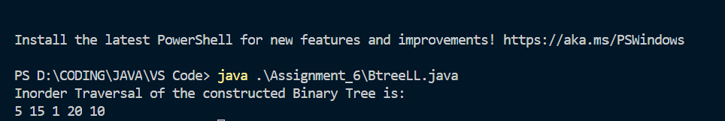

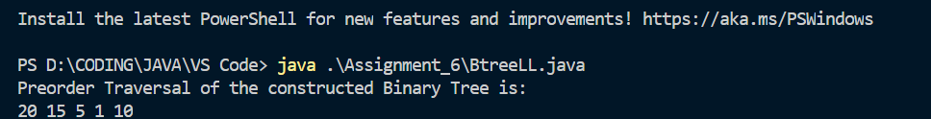



3. Write java code to insert a node in a binary tree (at internal nodes location)

CODE:

import *java*.*util*.*LinkedList*;

import *java*.*util*.*Queue*;

*public* *class* InsertInBTree {

    // *Java program to insert element in binary tree*

    /* *A binary tree node has key, pointer to*

*left child and a pointer to right child* */

*static* *class* Node {

        int key;

        Node left, right;

        // *constructor*

*Node*(int key)

        {

            this.*key* = key;

            left = null;

            right = null;

        }

    }

*static* Node root;

*static* Node temp = root;

    /* *Inorder traversal of a binary tree*\*/

*static* void *inorder*(Node temp)

    {

*if* (temp == null)

*return*;

*inorder*(temp.*left*);

        System.*out*.*print*(temp.*key* + " ");

*inorder*(temp.*right*);

    }

*static* void *preorder*(Node temp)

    {

*if* (temp == null)

*return*;

        System.*out*.*print*(temp.*key* + " ");

*preorder*(temp.*left*);

*preorder*(temp.*right*);

    }

*static* void *postorder*(Node temp)

     {

*if*(temp == null)

*return*;

*postorder*(temp.*left*);

*postorder*(temp.*right*);

        System.*out*.*print*(temp.*key*+" ");

    }

    /\**function to insert element in binary tree* */

*static* void *insert*(Node temp, int key)

    {

*if* (temp == null) {

            root = *new* *Node*(key);

*return*;

        }

        Queue<Node> q = *new* LinkedList<Node>();

        q.*add*(temp);

        // *Do level order traversal until we find*

        // *an empty place.ei*

*while* (!q.*isEmpty*()) {

            temp = q.*peek*();

            q.*remove*();

*if* (temp.*left* == null) {

                temp.*left* = *new* *Node*(key);

*break*;

            }

*else*

                q.*add*(temp.*left*);

*if* (temp.*right* == null) {

                temp.*right* = *new* *Node*(key);

*break*;

            }

*else*

                q.*add*(temp.*right*);

        }

    }

    // *Driver code*

*public* *static* void *main*(String args[])

    {

          /* *Our tree from this input before insertion will look something like this*

*69*

*/    *

*/      *

*/        *

*9              5*

*/               /   *

*/               /     *

*96               3*

*/

        root = *new* *Node*(69);

        root.*left* = *new* *Node*(9);

        root.*left*.*left* = *new* *Node*(96);

        root.*right* = *new* *Node*(5);

        root.*right*.*left* = *new* *Node*(3);

        System.*out*.*print*(

            "Inorder traversal before insertion: ");

*inorder*(root);

        int key = 12;

*insert*(root, key);

        int key1 = 19;

*insert*(root, key1);

        /* *Our tree from this input before insertion will look something like this*

*69*

*/    *

*/      *

*/        *

*9              5*

*/   \           /   *

*/     \         /     *

*96      12       3*

*69*

*/    *

*/      *

*/        *

*9              5*

*/   \           /   *

*/     \         /     *

*96      12       3       19*

*/

        System.*out*.*print*(

            "\nInorder traversal after insertion: ");

*inorder*(root);

    }

}

OUTPUT:

(Inorder)



(Preorder)

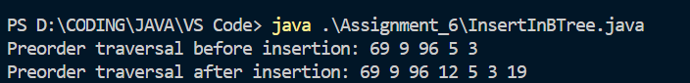

(Postorder)



4. Write a java code to delete a node in a binary tree (at internal nodes location).

CODE:

*public* *class* BinaryTreeNode {

*class* Node {

        int data;

        Node left, right;

*public* *Node*(int item) {

            data = item;

            left = right = null;

        }

    };

    Node root;

*BinaryTreeNode*() {

        root = null;

    }

*private* Node *insert_rec*(int d, Node r) {

*if*(r == null) {

*return* *new* *Node*(d);

        }

*else* {

*if*(d<r.*data*)

                r.*left* = *insert_rec*(d,r.*left*);

*else*

                r.*right* = *insert_rec*(d,r.*right*);

*return* r;

        }

    }

*public* void *insert*( int d) {

        root = *insert_rec*(d,root);

    }

*public* boolean *isLeaf*(){

*return* (root.*right*==null && root.*left*==null);

    }

*private* void *inorder_rec*(Node r) {

*if*(r==null){

            // *System.out.print("-");*

        }

*else* {

*inorder_rec*(r.*left*);

            System.*out*.*print*(r.*data*+" ");

*inorder_rec*(r.*right*);

        }

    }

*public* void *inorder*() {

        System.*out*.*println*("Inorder traversal of the binary tree is: ");

*inorder_rec*(root);

        System.*out*.*println*();

    }

*private* void *preorder_rec*(Node r) {

*if*(r==null){

            // *System.out.print("-");*

        }

*else* {

            System.*out*.*print*(r.*data*+" ");

*preorder_rec*(r.*left*);

*preorder_rec*(r.*right*);

            }

    }

*public* void *preorder*() {

        System.*out*.*println*("Preorder traversal of binary tree is: ");

*preorder_rec*(root);

        System.*out*.*println*();

    }

*private* void *postorder_rec*(Node r) {

*if*(r==null){

            // *System.out.print("-");*

        }

*else* {

*postorder_rec*(r.*left*);

*postorder_rec*(r.*right*);

            System.*out*.*print*(r.*data*+" ");

        }

    }

*public* void *postorder*() {

        System.*out*.*println*("Postorder traversal of binary tree is: ");

*postorder_rec*(root);

        System.*out*.*println*();

    }

*public* int *min*(Node r) {

*while*(r.*left* != null)

            r=r.*left*;

*return* r.*data*;

    }

*public* int *max*(Node r) {

*while*(r.*right* != null)

            r=r.*right*;

*return* r.*data*;

    }

*private* Node *delete_rec*(int key, Node r) {

*if*(r==null)

*return* r;

*else* *if*(key<r.*data*)

            r.*left* = *delete_rec*(key,r.*left*);

*else* *if*(key>r.*data*)

            r.*right* = *delete_rec*(key,r.*right*);

*else* {

*if*(r.*left*==null)

*return* r.*right*;

*else* *if*(r.*right*==null)

*return* r.*left*;

*else* {

                r.*data* = *min*(r.*right*);

                r.*right* = *delete_rec*(r.*data*,r.*right*);

            }

        }

*return* r;

    }

*public* void *delete*(int k){

*delete_rec*(k,root);

    }

*public* *static* void *main*(String []args){

        BinaryTreeNode b = *new* *BinaryTreeNode*();

        b.*insert*(5);

        b.*insert*(7);

        b.*insert*(6);

        b.*insert*(2);

        b.*insert*(10);

        /* *Our tree from this input before insertion will look something like this*

*5*

*/    *

*/      *

*/        *

*2           7*

*/   *

*/     *

*6      10*

*/

        b.*delete*(5);

            /* *Our tree after deletion of node with value 5 will look something like this*

*6*

*/    *

*/      *

*/        *

*2           7*

*\*

*\*

*10*

*/

        b.*inorder*();

        b.*preorder*();

        b.*postorder*();

    }

}

OUTPUT:

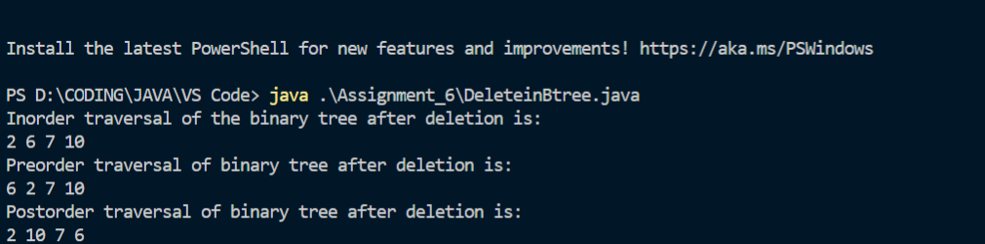

**THANK YOU!!**